Home

**REQUIREMENTS DOCUMENT FOR THE DESIGN AND IMPLEMENTATION OF A USSD AND MOBILE APP FOR THE PUBLIC PENSIONS FUND.**

Date: 19th December, 2022

Contents

Application overview. 3

Objectives of the Assignment. 3

Functional requirements. 3

1. USSD Application. 3

**a)** **Active members.** 3

**b)** **None Active members / Pensioners** 3

2. Mobile Application 3

Web Back end application. 4

None Functional Requirements. 4

Required User Interfaces. 5

Project Scope 5

Project deliverables in phases. 5

Software Architecture Diagram / Interactions with other systems. 6

# Application overview.

PSPF intend to modernize its operation to improve the integration with its members via USSD and mobile application for both active members and pensioners. The system will interface with Microsoft dynamics NAV.

## Objectives of the Assignment.

The main objective of the assignment is to design, develop and implement a USSD and mobile application to run on IOS and Android phones and tables used by the PSPF members and pensioners.

# Functional requirements.

## USSD Application.

The USSD application will be used by Active and none active members.

## **Active members.**

* The system will allow an active member to view his/ her social security number.
* The system will allow an active member to view a summary of contributions.
* The system will allow an active member to view types of loans( loan requirements, types of loans( Micro fin loans, mortgages and Agric Loans)
* The system will allow an active member to raise a complaint and make a suggestion as well as rate the company services.
* The system will allow an active member to view a loan statement summary.
* The system will allow an active member to view PSPF branch locations.
* The system will allow an active member to register as a user on the platform.
* The system will allow a member to initiate a loan.
* The system will allow a member to check the status of a complaint by complaint number.

## **None Active members / Pensioners**

* The system will allow a pensioner to view his/ her social security number.
* The system will allow a pensioner to check a file status.
* The system will allow a pensioner to lodge a complaint.
* The system will allow a pensioner to view PSPF branch locations.
* The system will allow a pensioner to view most recent pension statement summary.
* The system will allow a member to view life certificate expiry dates.
* The system will allow a member to check a file status of a deceased member.
* The system will allow a member to check the status of a complaint by complaint number.

## Mobile Application

* The Mobile App will allow a member to register an account.
* The Mobile App will allow a member to check / view their Social security number.
* The Mobile App will allow a member to update and view member information( contact information, NRC, and other personal information)
* The Mobile App will allow a member to raise a complaint and make a suggestion as well as rate the company services.
* The Mobile App will allow a pensioner to check a file status.
* The Mobile App will allow a member to view PSPF branch locations.
* The Mobile App will allow a member to view a loan statement for a selected date period.
* The Mobile App will allow a member to view pension statements for a selected date period.
* The mobile App will allow an active member to view types of loans( loan requirements, types of loans( Micro fin loans, mortgages and Agric Loans)
* The mobile App will allow a member to view a loan calculator.
* The mobile app will allow a member to upload / submit a life certificate.
* The mobile App will allow a member to submit a death records/notice of death of a member.
* The mobile App will allow a member to initiate a loan.
* The mobile App will allow a member to check the status of a complaint by complaint number.
* The Mobile App will allow a member to download files (Loan files, etc).
* The Mobile App will allow members to check a file status of a deceased member.

## Web Back end application.

* The system shall allow a user to view reports.
* The system shall allow a user to push notifications to users from the web Application.
* The system shall enable a user to view complaints, suggestions and ratings from customers.
* The system shall enable a user to upload downloadable documents for customers, loan forms, etc.
* The system shall enable a user to provide feedback to a complaint.
* The system shall enable a user to view deceased cases records from the ussd and mobile apps.

# None Functional Requirements

**Usability-** The system should have a simple user interface that follows for ease of data entry. The system should be parameter and configuration driven.

**Security-** The system shall be designed with a level of security appropriate for the sensitivity of information enclosed in the database. The application will need to be programmed with best practices to avoid SQL injection attacks and other internet hacking and attacks that can take place, a possible penetration testing would be a good idea.

**Performance**- The System is expected to be of best performance with loading time for all pages and requests this can be achieved with good programming practice.

**Cross platform compatibility**- The application needs to be compatible with any screen size and any device i.e. phone, tablet or computer that is IOS and Android.

**Extensibility** – The System will be expected to be built in a way that it can be easily extended and easy to integrate to other systems.

# Required User Interfaces.

System is required to be accessible from the platforms listed below:

1. Android
2. IOS Mobile.
3. USSD
4. Web application for back end administration.

# Project Scope

Below is the scope of the project.

1. Gather requirements, specifications and analyze and produce prototypes.
2. Design and develop a USSD and Mobile Application ( Android and IOS)
3. Integrating the system to Microsoft Dynamics NAV.
4. Design and develop system Administration backend.
5. Provide reporting capabilities.
6. Testing of the system
7. Deployment of the system.
8. Administrators training.

## Project deliverables in phases.

|  |  |  |
| --- | --- | --- |
| **Milestone Number** | **Deliverable** | **Phase** |
| 1 | Requirements documentation and Design of System. | Phase 1 |
| 2 | Project road map document. |
| 3 | API Development. |  |
| 4 | Implementation of fully functional Mobile Applications ( Android and IOS) | Phase2 |
| 5 | Implementation of fully functional USSD Application. |
| 6 | Training | Phase 3 |
| 7 | System documentations and hand over notes ( user manuals, technical reports) |
| 8 | Sign off document |
| 8 | Support for three months |

# Software Architecture Diagram / Interactions with other systems.

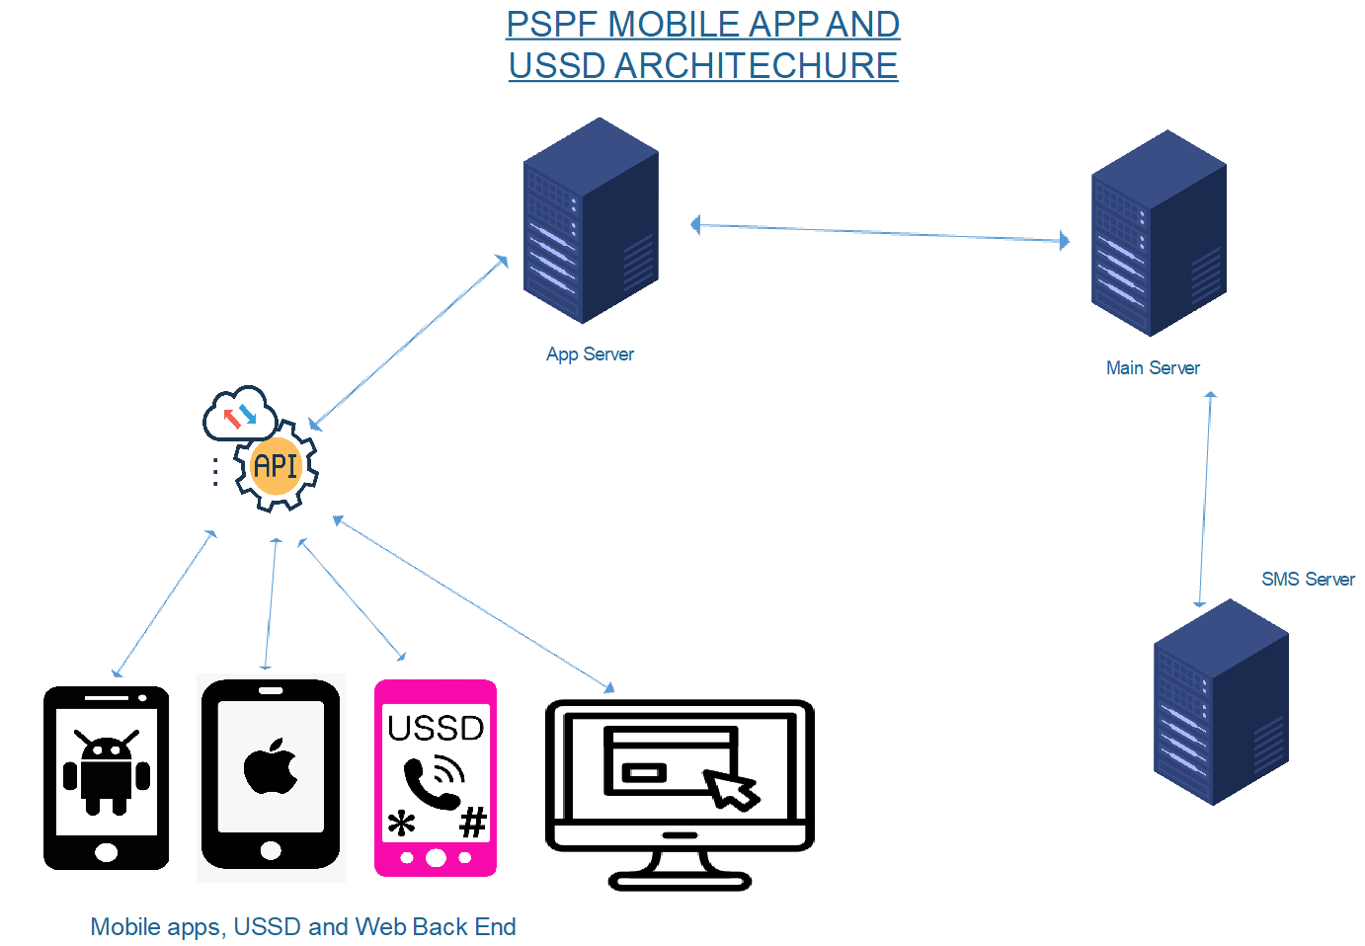

**Requirements Sign off Chesco-Tech:** 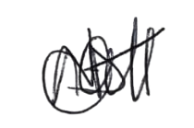

**Date: 31 December, 2022.**

**Requirements sign off PSPF:**

**Date:**